Build a Pie Chart

Use pie charts to show proportions of a whole.

The basic building blocks for a pie chart are as follows:

|  |  |
| --- | --- |
| **Mark type**: | Pie |
| **Color**: | Dimension |
| **Angle**: | Measure |

To create a pie chart view that shows how different product categories contribute to total sales, follow these steps:

1. Connect to the **Sample - Superstore** data source.
2. Drag the **Sales** measure to **Columns**.

Tableau aggregates the measure as a sum.

1. Drag the **Sub-Category** dimension to **Rows**.

The default chart type is a bar chart.

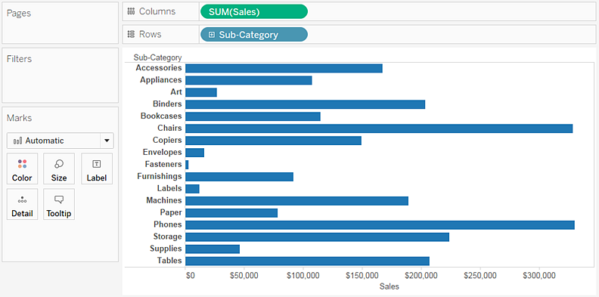

1. Click **Show Me** on the toolbar, then select the pie chart type.

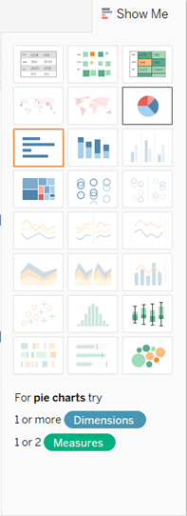

The result is a rather small pie:

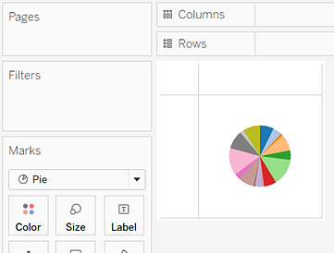

1. To make the chart bigger, hold down Ctrl + Shift (hold down  +  on a Mac) and press B several times.
2. To add labels, drag the **Sub-Category** dimension from the **Data** pane to **Label** on the **Marks** card.

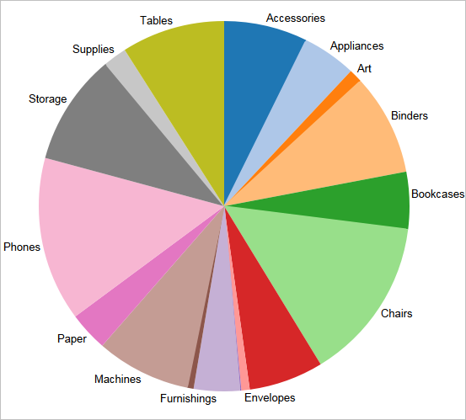

1. If you don't see labels, press Ctrl + Shift + B (press  +  + B on a Mac) to make sure most of the individual labels are visible.

You can make a pie chart interactive in a dashboard. For more information, see [Actions and Dashboards](https://onlinehelp.tableau.com/current/pro/desktop/en-us/actions_dashboards.html).

**Note:** Pie charts can also be used as a mark type in a visualization. For more information, see [Pie mark](https://onlinehelp.tableau.com/current/pro/desktop/en-us/viewparts_marks_marktypes.html#PieMark).